5.3.1 Tangent Lines & Arc Lengths of Polar Curves

Tangent Lines of Polar Curves

Motivation: Consider an arbitrary polar curve C of the form . Suppose we want to find the equation of a tangent line to some point on the curve.

To do this, we will have to calculate . This will be possible if we view as a parameter and note that the curve C is also given by the parametric equations: . Then, we can use the methods of section 7.2 to calculate .

Theorem: In order to find the slope of a tangent line on a polar curve at a given angle we calculate:

provided that

Note: The product rule is being used to find and .

Example 1: For the cardioid find the slope of the tangent line at the point .
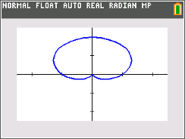
We have that and .
Thus, we have that and. We note that . Thus, the answer is:

Example 2: Find the points on the cardioid , on the interval where there are horizontal & vertical tangent lines and singular points.

Remember: . We must first find when .

So we need | So we need

Horizontal tangent lines:

There are horizontal tangents at:

Vertical tangent line
There are vertical tangents at:

Singular points
There is a singular point at:

Note: We could show, through evaluation of limits, that there is a vertical tangent line at this point as well. Since details of this are omitted in the textbook we will also omit the details and just consider this as a “singular point”.

Example 3 (you try): Find the points on the curve given by from where there are horizontal & vertical tangent lines and singular points.

Remember: . We must first find when .

So we need | So we need

Horizontal tangent lines:
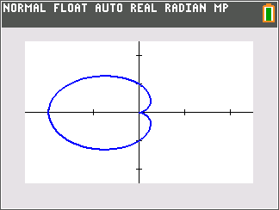
There are horizontal tangents at:

Vertical tangent line
There are vertical tangents at:

Singular points
There is a singular point at:

Example 4: The three-petal rose has three tangent lines at the origin. Find the polar equation which represents each of these lines.

Any line tangent to the origin must go through the point . Therefore and we must solve the equation:
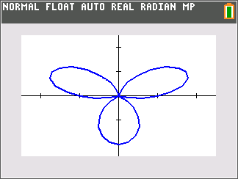
So

We note that in polar graphs is the equation of a line since the angle is fixed and the radius can take on any value.

Arc Length of Polar Curves

Motivation: We now consider the arc length of a polar curve.

Suppose we wish to find the length of a polar curve where . We can view the curve in terms of parametric equations as:

.

We know from section 7.2 that the desired length will be given by: . We can simplify this formula quite a bit by doing the following calculation:

.

This leads to the following formula.
Formula: The length of a curve with polar equation where , is

.

Example 5 (you try):
- Find the length of one tracing of the cardioid given by . You may use a calculator to approximate the value of the definite integral.

First, we can see from the calculator and the function that the curve will be completely traced for .
We calculate that . Now, we apply the formula that we derived above and obtain:


- How would the problem change if you were working with function ?

This function is traced exactly once for , so we would have the integral:

Example 6 (you try):
Find the exact length of the cardioid given by where . You may use a calculator to approximate the value of the definite integral.

First, we note that . Now, we apply the formula that we derived above and obtain:
